SSDL CALIBRATION SERVICES REQUEST FORM

OR # __________

Date ___________

Instructions:
- Fill-out ALL the fields below and check ✓ the box that corresponds to your facility.
- Please write legibly. All information written in this form will be the basis of the certificate/report issued.

- Instrument Details

Type of Instrument | Field of Application
Dose rate meter / Survey Meter  Type of Radiation  Gamma  Neutron  Contamination Meter  Active Personal Dosimeter  Type of Radiation  Gamma  Neutron  Rate Alarm  Activity Meter  For Brachytherapy  Source Output Measurement  Well-type Chamber Calibration | MEDICAL | INDUSTRIAL
 | Nuclear Medicine  Conventional Diagnostic Radiology (Conventional Radiological, CT Scan, Special Exam Radiology, Urology, Endoscopy, Mammography, etc.)  Interventional Procedure (e.g., Cardiovascular)  Radiotherapy (e.g., Brachytherapy, Teletherapy)  Dental Practice  Veterinary Medicine | Industrial X-ray (Electronics, etc.)  Radioisotope production/distribution (e.g., Production/ distribution of I-131, Tc-99m, etc.)  Industrial Radiography (NDT, weld/pipe/concrete testing, etc.)  Industrial gauges (Density/thickness/level gauge, etc.)  Accelerator operation
 |  | OTHERS

Manufacturer | Model / Probe Model | Serial Number / Probe Serial Number | Check ✓ box if with
 |  |  | Case | Probe cover | Charger

- Customer Information
Company Name:
Address:
Contact Person: |  |  |  |  | Designation:
Contact Number: |  |  |  | Email Address:

- Terms and Conditions

- Radiation Monitoring Instruments submitted for calibration must have a NEW SET OF BATTERIES or CHARGER. It should also PASS the PRE-RESPONSE TESTS such as battery, HV, and source checks.
- The Institute is implementing a CASH PAYMENT POLICY. The services being requested will be provided only upon presentation of the official receipt.
- Schedule of calibration, as applicable, shall be subject to availability of CUSTOMER vehicle.
- The Certificate of Instrument Calibration will be released 15 working days after receipt of radiation monitoring instruments and 10 working days after the conduct of service for Activity Meter and Brachytherapy.
- The Institute will not be liable for any damage incurred on UNCLAIMED INSTRUMENTS three (3) months after the date of calibration.
- If there are no complaints regarding the calibration ONE (1) WEEK upon release of certificate, it shall be considered acceptable.
- PNRI has no control over shipment of instruments from and to the client. PNRI is not responsible for any issues with the delivery (e.g., packing an instrument that did not undergo pre-response, incomplete requirements, etc.). Please see SSDL CALIBRATION SERVICES Annex: Packing of Instrument for guidelines.

I have read and agreed with all the terms and conditions stated above.

______________________________________________ ________________ ____________________________________
Signature over Printed Name of Applicant Date RPSS Receiving Personnel
SSDL CALIBRATION SERVICES

Annex

Packing of Instrument

It is important to pack the radiation monitoring instruments correctly to protect it from damage/s during transportation. Below are the requirements and packing guidelines for the instrument. Failure to adhere may cause damage (e.g., punctured detector). This Annex document is only for radiation monitoring instruments that will be sent via courier to PNRI-RPSS for calibration.

Please be reminded that PNRI is not responsible of packing the instruments back to the customer.

Customer check ✓ box | To be checked by RPSS Personnel upon opening of package | Categories
 |  | Mandatory Documents | This Checklist
 |  |  | Application Form – One (1) Copy
 |  |  | Payment - Cheque ONLY
 |  | Packing guidelines | Conduct visual checking. Make sure that are no damages on the instruments
 |  |  | Remove the battery from the instrument. This prevents leaking of batteries if there are delays. | 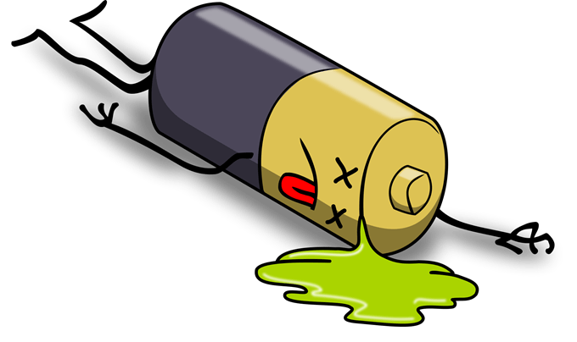
 |  |  | Choose a box strong enough to hold the contents. That means it should not have tears, rips, bends, or other damage. New corrugated box is preferred.
 |  |  | Select and use proper cushioning materials for package contents. Wrap items individually and surround them with bubble sheeting and recyclable or foam loose-fill materials. Content should not directly touch the inside of the shipping box. | 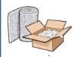
 |  |  | Securely seal the package with strong tape.
 |  |  | Use pressure-sensitive plastic or nylon reinforced tape. Two (2) inches or 5.08 cm wide tape is enough to secure the box
 |  |  | Do not forget to remove all the labels if re-using boxes

_________________________________________ ________________ _____________________________
Signature over Printed Name of Applicant Date RPSS Receiving Personnel

